
EYFS 2024/25 Whole Year Coverage- suggested but not exhaustive activities.
Characteristics of Effective Learning:
Playing and Exploring
*Realise that their actions have an effect on the world, so they want to keep repeating them.; * Plan and think ahead about how they will explore or play with objects. * Guide their own thinking and actions by talking to themselves while playing. *Make independent choices. *Bring their own interests and fascinations into early years settings. This helps them to develop their learning. *Respond to new experiences that you bring to their attention.
Active Learning
*Participate in routines and begin to predict sequences because they know routines. *Show goal-directed behaviour. *Begin to correct their mistakes themselves. *Keep on trying when things are difficult.
Take part in simple pretend play.
•Creating and Thinking Critically
*Sort materials. *Review their progress as they try to achieve a goal and check how well they are doing. *Solve real problems. *Use pretend play to think beyond the ‘here and now’ and to understand another perspective.
*Know more, so feel confident about coming up with their own ideas. Make more links between those ideas. *Concentrate on achieving something that’s important to them. They are increasingly able to control their attention and ignore distractions.
Autumn 1    Incredible Me! | Autumn 2  Towers and Turrets  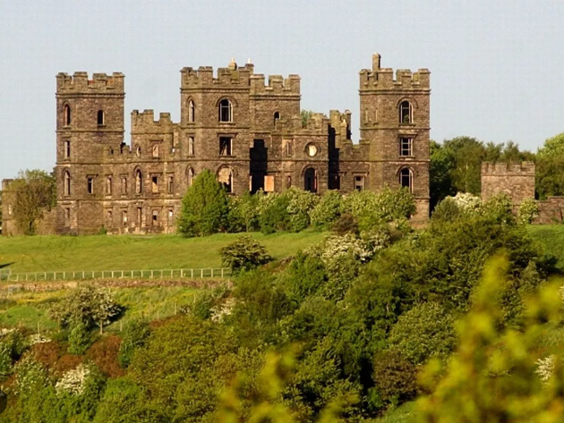 | Spring 1  Shiver Me Timbers!  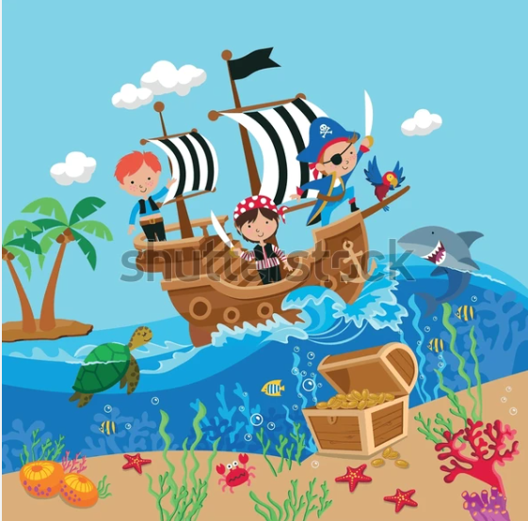 | Spring 2  London’s Burning  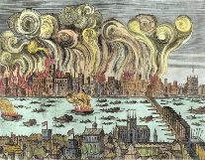 | Summer  Travel and Transport  
Prime Area: Personal, Emotional and Social Development
Show an understanding of their own feelings and those of others, and begin to regulate their behaviour accordingly. Set and work towards simple goals, being able to wait for what they want and control their immediate impulses when appropriate. Give focused attention to what the teacher says, responding appropriately even when engaged in activity, and show an ability to follow instructions involving several ideas or actions. Be confident to try new activities and show independence, resilience and perseverance in the face of challenge. Explain the reasons for rules, know right from wrong and try to behave accordingly. Manage their own basic hygiene and personal needs, including dressing, going to the toilet and understanding the importance of healthy food choices. Work and play cooperatively and take turns with others. Form positive attachments to adults and friendships with peers. Show sensitivity to their own and to others’ needs.
* Identify what makes us ‘incredible’  * Thinking about who is in our families and where we fit in;  * Exploring the concept of identity and what makes us who we are;  * Identify our favourite things- foods, colours, stories etc. | * Think about the people who keep us safe at home and at school  * Learning ‘top tips’ for keeping safe in the kitchen  * Talking about what we should do in an emergency and how the emergency services  * Keeping safe with fireworks, rivers and gardens which we enjoy  * Giving advice to story characters | * comparing fantasy and traditional stories;  * considering behaviour of characters and evaluating their decisions;  * thinking about why medicines are important and how to stay safe around them;  * thinking about the changes that take place as we grow up | * Finding out about our own likes and dislikes and how they might differ from our friends;  * Celebrating our similarities and differences;  * Learning how we keep ourselves safe, including taking part in a fire drill;  * Thinking of ways to help our friends. | * name and recognise different feelings;  * describe our feelings as we win and lose party games;  * understanding why rules are important;  * explore ways to look after our environment.
Prime Area: Communication and Language • Understand how to listen carefully and why listening is important. • Learn new vocabulary. • Use new vocabulary through the day. • Ask questions to find out more and to check they understand what has been said to them. • Articulate their ideas and thoughts in well-formed sentences. • Connect one idea or action to another using a range of connectives. • Describe events in some detail. • Use talk to help work out problems and organise thinking and activities, and to explain how things work and why they might happen. • Develop social phrases. • Engage in story times. • Listen to and talk about stories to build familiarity and understanding. • Retell the story, once they have developed a deep familiarity with the text, some as exact repetition and some in their own words. • Use new vocabulary in different contexts. • Listen carefully to rhymes and songs, paying attention to how they sound. • Learn rhymes, poems and songs. • Engage in non-fiction books. • Listen to and talk about selected non-fiction to develop a deep familiarity with new knowledge and vocabulary.
* Using the role play corner to act out different home scenarios and become different people within the story;  * Retell familiar stories independently  * Sing familiar songs as part of a group;  * Negotiate within a small group as we design pizza toppings for all to enjoy. | * Performing poems we have learned  * Taking on the roles of shop keeper and customer to play in our shop  * Role playing life in a Medieval castle  * Learning our words and music for the Nativity | * role playing in a pirate ship, dressing as pirates, commanding a crew and walking the plank.  * re-tell familiar stories in the correct order;  * read a range of simple words and sentences independently;  * following and giving instructions to complete a task  * performing using a range of puppets | * role playing in a fire station, responding to calls and putting out fires;  * saying familiar rhymes with confidence;  * using a story map to retell a familiar story  * read a range of simple words and sentences independently; | *Learn Makaton signs to add to our poetry recitals:  * record our poems using talking tins for others to enjoy;  * send a message to themselves in the form of a postcard with key features;  * think about what makes a good performance and how an audience might appropriately respond.
Prime Area:: Physical Development
• Revise and refine the fundamental movement skills they have already acquired: - rolling - crawling - walking - jumping - running - hopping - skipping - climbing • Progress towards a more fluent style of moving, with developing control and grace. • Develop the overall body strength, co-ordination, balance and agility needed to engage successfully with future physical education sessions and other physical disciplines including dance, gymnastics, sport and swimming. • Develop their small motor skills so that they can use a range of tools competently, safely and confidently. Suggested tools: pencils for drawing and writing, paintbrushes, scissors, knives, forks and spoons. • Use their core muscle strength to achieve a good posture when sitting at a table or sitting on the floor. • Combine different movements with ease and fluency. • Confidently and safely use a range of large and small apparatus indoors and outside, alone and in a group. • Develop overall body-strength, balance, co-ordination and agility. • Further develop and refine a range of ball skills including: throwing, catching, kicking, passing, batting, and aiming. • Develop confidence, competence, precision and accuracy when engaging in activities that involve a ball. • Develop the foundations of a handwriting style which is fast, accurate and efficient. • Further develop the skills they need to manage the school day successfully: - lining up and queuing – mealtimes.
* Explore our senses using a range of play equipment;  * Building gross motor skills such as balancing, throwing and catching, and making shapes using different body parts;  * use a range of kitchen tools to develop fine motor skills;  * Exploring and controlling bigger toys in the playground. | * Use small world plays sets of castles with knights and horses  * Use equipment such as scissors and split pins to make puppets  * jumping, rolling and balancing on the floor and gymnastics equipment;  * children to use mark making implements to draw and paint fireworks; | * develop balance, co-ordination and body strength through dance;  * use tweezers, chop sticks and scoops to hunt for treasure;  * use a range of pens, pencils and chalks to develop fine motor skills;  * begin to use the Letterjoin scheme activities to develop handwriting skills; | * develop ball skills and teamwork through learning to play tennis;  * learning to dress and undress in order to wear clothing for fighting fires;  * use a range of pens, pencils and charcoal to develop fine motor skills;  * begin to use the Letterjoin scheme activities to develop handwriting skills;  * small world towns and bricks to build a new London | * Throwing and catching skills with balls and beanbags;  * Teambuilding skills, including baton passing;  * Running and skipping skills, using hoops;  * Balancing in different parts of the body;  * Types of jump and how to execute them safely;
Specific Area: Literacy
Read individual letters by saying the sounds for them. • Blend sounds into words, so that they can read short words made up of known letter-sound correspondences. • Read some letter groups that each represent one sound and say sounds for them. • Read a few common exception words matched to the school’s phonic programme. • Read simple phrases and sentences made up of words with known letter–sound correspondences and, where necessary, a few exception words. • Re-read these books to build up their confidence in word reading, their fluency and their understanding and enjoyment. • Form lower-case and capital letters correctly. • Spell words by identifying the sounds and then writing the sound with letter/s. • Write short sentences with words with known letter-sound correspondences using a capital letter and full stop. • Re-read what they have written to check that it makes sense.
* Use information from non-fiction books and posters to sort our animal toys who are nocturnal or diurnal;  * Draw pictures for our own versions of ‘Little Rabbit Foo Foo’ and ordering words in a sentence to tell it;  * Ordering animal names alphabetically;  * Sharing and reviewing Mog the cat stories and talking about their own ideal pets. | *Labelling farm animals  *Using non-fiction texts to find out about farms  * Enjoying traditional and nonsense poems and finding rhyming pairs and repeating patterns  * develop pencil control using firework patterns to trace;  * use talking tins to record nursery rhymes;  * write a group poem by finding rhyming words for activities we enjoy;  * mark making using paints, pencils and chalks to make patterns; | * developing our own story maps to tell different versions of familiar stories;  * use fantasy story language we have learned to create new characters;  * play games like ‘Simon says’ and board games to practice following instructions;  * give instructions to others using ‘bossy verbs’ to make rice crispy cakes  * noticing punctuation in texts, including question and exclamation marks | * identify question marks and exclamation marks; when they are used and how they change the way we read a sentence;  *describe the taste of fruit and vegetables and using the words to create similies;  * think about how colours can be used to represent different emotions and find colours to show how we feel;  * finding rhyming strings in familiar poems and songs. | *write themselves a postcard and post it at the post box;  *sort toy animals according to their features and label them;  *create African animal masks;  *use a range of non-fiction texts to find out about African animals  * alphabet jigsaws  * learn a nonsense poem and perform it to the class (and other poems ready for the school poetry recital;  Order events in the life of Edward Lear
Specific Area: Mathematics
• Count objects, actions and sounds. • Subitise. • Link the number symbol (numeral) with its cardinal number value. • Count beyond ten. • Compare numbers. • Understand the ‘one more than/one less than’ relationship between consecutive numbers. • Explore the composition of numbers to 10. • Automatically recall number bonds for numbers 0-5 and some to 10. • Select, rotate and manipulate shapes to develop spatial reasoning skills. • Compose and decompose shapes so that children recognise a shape can have other shapes within it, just as numbers can. • Continue, copy and create repeating patterns. • Compare length, weight and capacity.
* Estimate and count groups of objects, and find out that it is easier to count them in a line;  * Find 2D shapes in the playground;  *Use 2D shapes to create pictures;  * Explore numicon pieces and match to numerals;  *Create a train journey for teddies to count passengers on and off the train. | * Comparing and measuring longer and shorter lengths using non-standard units such as cubes and bricks, and measuring lots of objects around the classroom  * Naming 3D shapes and using blocks to build  * Sorting and recognising coins and their values | * racing snails and other animals and recording their positions;  * looking for 2D and 3D shapes in the environment and taking photos of them;  * using paint to create symmetrical butterfly paintings;  * estimating how many sweets are on the plate and finding out if there are enough to share, | *making patterns with compare bears in different colours and sizes;  *constructing 3D shapes using building blocks and making 3D animal shapes using paper;  * using the bucket balance to estimate and weigh classroom objects;  * using maths vocabulary such as ‘balance’, ‘equal’, ‘heavy’, ‘light’, ‘equal’. | * mix and serve each other delicious milkshakes in glasses that are ‘full’, ‘nearly full’ etc;  * using compare bears to create repeating colour and shape patterns and threading repeating fruit skewers;  * paint a number track to 20 and use it to count in 2s and 10s.  * blow out birthday candles 2 at a time
Specific Area: Understanding the World
• Talk about members of their immediate family and community. • Name and describe people who are familiar to them. • Comment on images of familiar situations in the past. • Compare and contrast characters from stories, including figures from the past. • Draw information from a simple map. • Understand that some places are special to members of their community. • Recognise that people have different beliefs and celebrate special times in different ways. • Recognise some similarities and differences between life in this country and life in other countries. • Explore the natural world around them. • Describe what they see, hear and feel whilst outside. • Recognise some environments that are different to the one in which they live. • Understand the effect of changing seasons on the natural world around them.
* Compare baby photographs of ourselves to images now and say what we are looking forward to doing when we are older;  * Finding where we live on a local area map;  * Learning about what Christians mean by ‘God’ and why this is important to them;  * Use our senses to sort a variety of fruits and vegetables;  * Compare homes from different cultures. | * Finding out about day to day life on a farm and the jobs that need doing to look after the animals  * Learning the features of a castle and what they were for  * Exploring and describing the materials that different objects are made from  * Tell the story of the Nativity  * Finding out what Christians believe God is like  * talk about how we celebrate Christmas in our own families and community; | * Enjoying playing and creating simple computer games;  * Comparing a pirate’s life with our own;  * Looking out for hazards in the home;  * Sorting and describing different animals and thinking about how we look after them;  * Using maps to find our way around the school as we look for treasure; | * Enjoying playing and creating simple computer games;  * Learning about fire safety in our own homes with the help of Dexter Dog;  * Learning the story of the Great Fire of London and how we know about what happened;  * Looking at things we like in the world and learning about what Christians believe about Creation;  * Observing the weather and seasonal changes | * explore and compare lots of different types of transport;  * plant and nurture different flowers and vegetables and learn about what they need to grow and be healthy;  * find out about how important wheels are to lots of types of transport and how they work;  * design and create our own vehicles using junk modelling equipment.
Specific Area: Expressive Arts and Design
• Explore, use and refine a variety of artistic effects to express their ideas and feelings. • Return to and build on their previous learning, refining ideas and developing their ability to represent them. • Create collaboratively, sharing ideas, resources and skills. • Listen attentively, move to and talk about music, expressing their feelings and responses. • Watch and talk about dance and performance art, expressing their feelings and responses. • Sing in a group or on their own, increasingly matching the pitch and following the melody. • Develop storylines in their pretend play. • Explore and engage in music making and dance, performing solo or in groups.
* Look carefully at ourselves in a mirror and draw our own faces;  * Design pizza toppings that will be enjoyed by our group;  * Use brushes and paints to paint some of our favourite things;  * Make play dough faces to express different emotions.;  * Make a medal for Mog the brave cat. | *design your own shield  *making finger puppets  *use pastels and pencils to draw our favourite castles  *fingerprint firework picture;  *chalk firework patterns;  *take part in the school Nativity performance  *decorate the Christmas tree using baubles and tinsel; | * Designing and making our own felt pirate puppets using simple sewing techniques;  * Drawing our own pirate maps;  * Creating and performing dances;  * Building an outdoor pirate ship;  * Enjoying blues, latin, folk and funk as we explore different musical styles from around the world. | - Using charcoal to create lines, patterns and shapes;  - Carefully observing drawings in order to create our own;  - Looking at the work of Paul Klee and using potato printing to create art about the Great Fire based on his work;  - Enjoying reggae music and introducing the glockenspiels. | - Explore the work of Jackson Pollock and use toys with wheels to print our own abstract pieces;  - Experiment with paint to create washes in different colours;  - Collage using different materials to create Titanic portholes;

