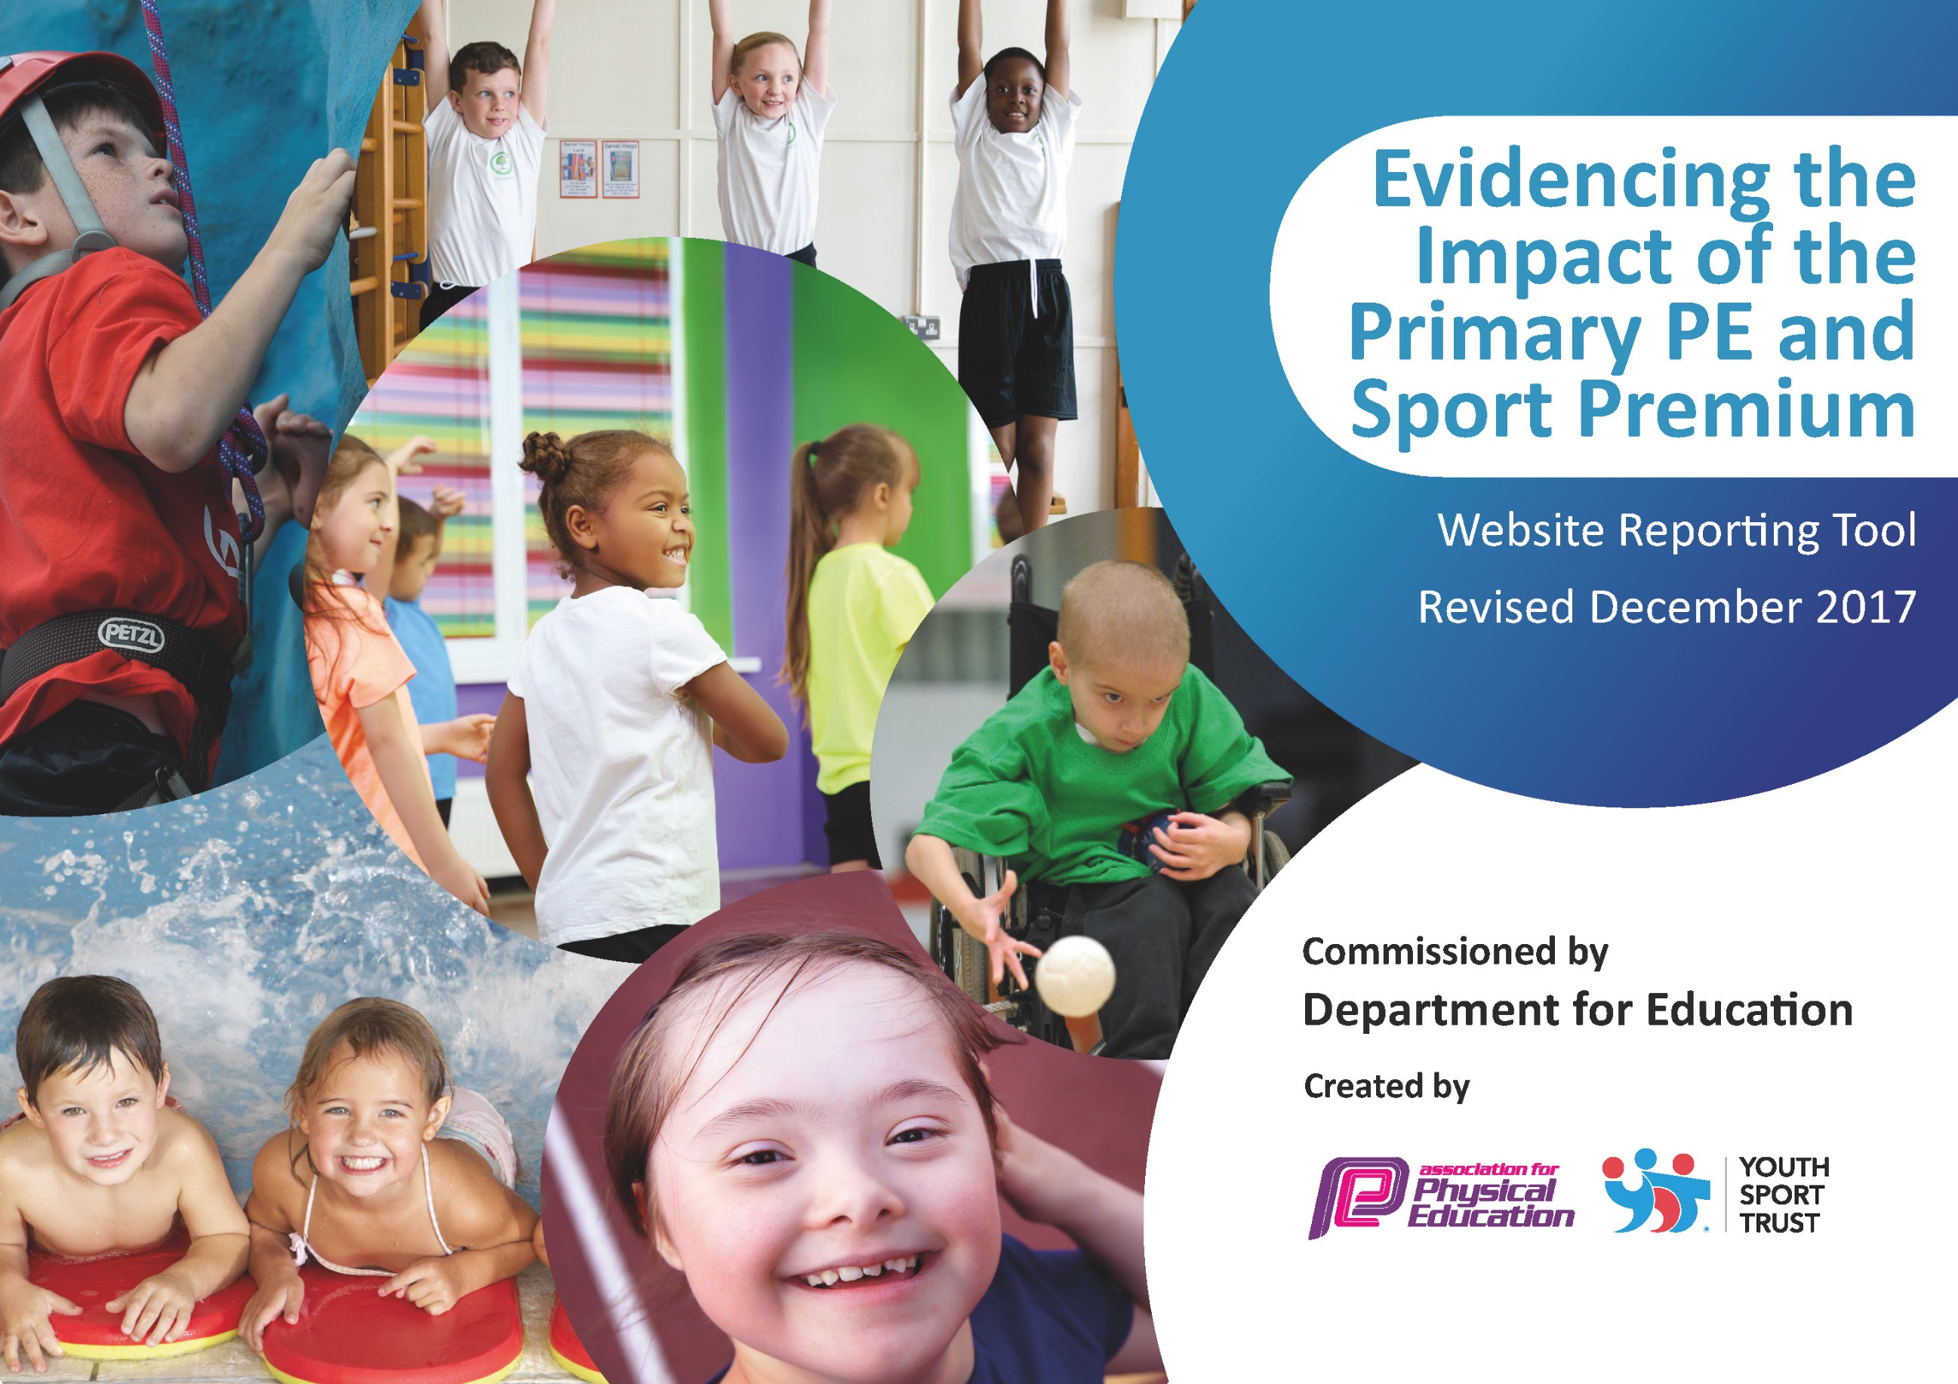

Schools must use the funding to make additional and sustainable improvements to the quality of PE and sport they offer. This means that you should use the Primary PE and Sport Premium to:

- develop or add to the PE and sport activities that your school already offers
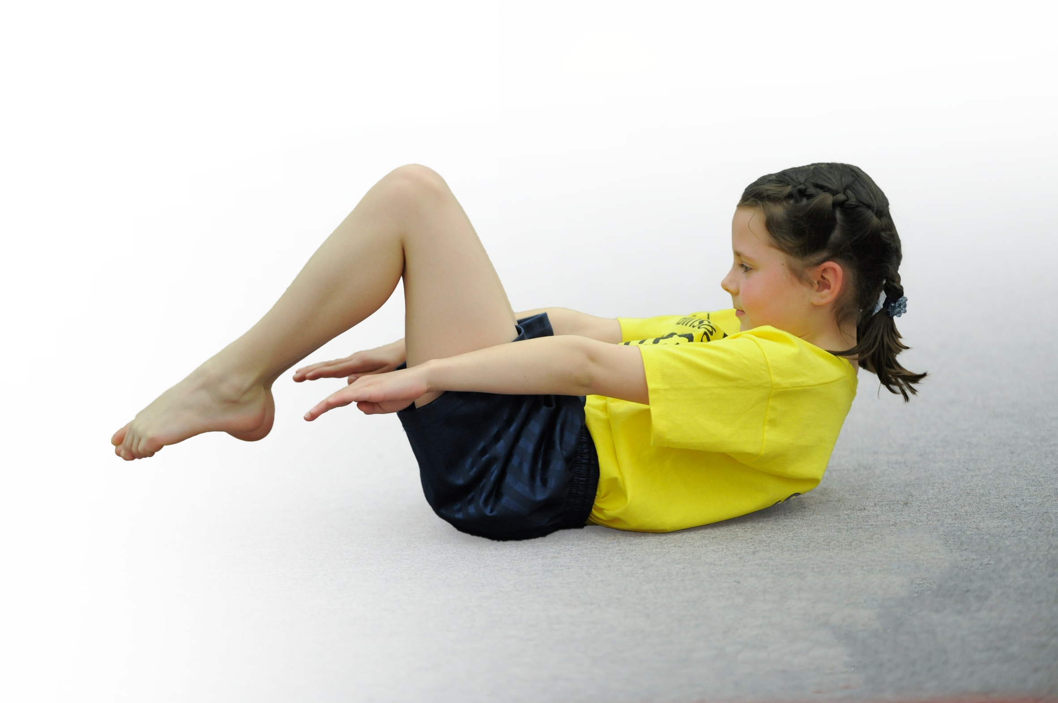
- build capacity and capability within the school to ensure that improvements made now will benefit pupils joining the school in future years

Please visit gov.uk for the revised DfE guidance including the 5 key indicators across which schools should demonstrate an improvement. This document will help you to review your provision and to report your spend. DfE encourages schools to use this template as an effective way of meeting the reporting requirements of the Primary PE and Sport Premium.

We recommend you start by reflecting on the impact of current provision and reviewing the previous spend.
Under the Ofsted Schools Inspection Framework, inspectors will assess how effectively leaders use
the Primary PE and Sport Premium and measure its impact on outcomes for pupils, and how effectively governors hold them to account
for this.

Schools are required to publish details of how they spend this funding as well as on the impact it has on pupils’ PE
and sport participation and attainment.
We recommend regularly updating the table and
publishing it on your website as evidence
of your ongoing review into how you are using the money
to secure maximum, sustainable impact. To see an example of how to complete the table please click HERE.

Support for review and reflection - considering the 5 key indicators from DfE, what development needs are a priority for your setting and your students now and why? Use the space below to reflect on previous spend, identify current need and priorities for the future.

Key achievements to date: | Areas for further improvement and baseline evidence of need:
Increasing the opportunities for children to participate in competitive sporting activities at all age levels.  Increasing the provision of high quality morning sports clubs.  Developing children’s fitness levels and awareness of health issues.  Increasing the skills and knowledge of staff by working with high-level coaches.  Using sport to promote good mental health for selected children | Continued promotion of fitness and the introduction of more activities to promote fitness, health and wellbeing.  Further developing pupil voice when planning the provision of our sports and PE.

Meeting national curriculum requirements for swimming and water safety | Please complete all of the below*:
What percentage of your current Year 6 cohort swim competently, confidently and proficiently over a distance of at least 25 metres? | 100%
What percentage of your current Year 6 cohort use a range of strokes effectively [for example, front crawl, backstroke and breaststroke]? | 100%
What percentage of your current Year 6 cohort perform safe self-rescue in different water-based situations? | 100%
Schools can choose to use the Primary PE and Sport Premium to provide additional provision for swimming but this must be for activity over and above the national curriculum requirements. Have you used it in this way? | Yes/No
*Schools may wish to provide this information in April, just before the publication deadline.

Action Plan and Budget Tracking
Capture your intended annual spend against the 5 key indicators. Clarify the success criteria and evidence of impact that you intend to measure to evaluate for students today and for the future.

Academic Year: 2022/23 | Total fund allocated: £16,560 | Date Updated: July 2023
Key indicator 1: The engagement of all pupils in regular physical activity – Chief Medical Officer guidelines recommend that primary school children undertake at least 30 minutes of physical activity a day in school |  |  |  | Percentage of total allocation:
 |  |  |  | 18.6%
School focus with clarity on intended impact on pupils: | Actions to achieve: | Funding allocated: | Evidence and impact: | Sustainability and suggested next steps:
All children should be active every day for at least 30 minutes. | Subsidised morning sports clubs from Qualitas to encourage more children to become more active.  Use of village hall to ensure better conditions for morning activities  Extra cost of allowing all junior year groups to attend swimming rather than just in one year, including transportation. Also targeting children to swim increased distances.  Break times have been changed to allow Infants and Juniors more time on the larger playground, enabling more physical activity.  Y5/6 having training so they can run activities for younger children.  Children / MDS running lunchtime exercise activities – e.g. multiskill games, Running, Aerobics, Skipping. Training and Development of School Sports Crew to deliver this. Purchase of t shirts for them.  Selected children to take part in a 6-week Active Minds program, tailored and delivered by Highfields staff in school. | £2000  £637  n/a  part of RDSSP buy-in  £100  £350 | Attendance at these clubs has continued to be strong and attracts children that are non-sporty as they enjoy the activities.  All children become competent in swimming and reach the required standard by the end of year 6.  Children have engaged in more creative physical games that were previously difficult to do.  Children have helped run lunchtime sporting activities  Children continued to really enjoy these activities and being part of the sports crew was a prestigious group to be a part of.  Children a lot more positive about activity and themselves. Some of these children now want to come to Morning Clubs. | Continue to ensure the quality and attendance of these. Develop into sports specific clubs so there is greater emphasis on learnt skills.  Continue to offer this provision as new juniors will enter the class each year.  Develop sessions where older children run activities for younger children.  Continue to offer transition support to the Y5 children to take over running activities from Y6  Involve the sports crew in the planning and running of these activities.
Key indicator 2: The profile of PE and sport being raised across the school as a tool for whole school improvement |  |  |  | Percentage of total allocation:
 |  |  |  | 8.5%
School focus with clarity on intended impact on pupils: | Actions to achieve: | Funding allocated: | Evidence and impact: | Sustainability and suggested next steps:
The whole school should celebrate sporting achievement and efforts with sport and activity being seen as something embedded in our provision to children as part of educating the whole child. | Attendance of Qualitas awards evening to celebrate children’s effort in sports sessions over the year, including the presentation of footballs and t-shirts.  Rental payment to South Darley Village hall and Darley Dale Cricket Clubs.  Sports Council to continue to run alongside the school council to organizes events and clubs, write articles for the school newsletter and maintain a noticeboard to tell other children of sporting event and achievements.  Our weekly ‘Celebrating our Week’ has a dedicated sports section with pictures and articles promoting sport within school. | £100  £1,210  £100  n/a | Children have been encouraged to put extra effort into their sports sessions so that they will earn an invitation to this event.  Children are able to enjoy high quality sports facilities in all weathers, promoting a greater enjoyment of sports. Parents see these places as extensions of the school’s facilities  T-shirts to give sportsleaders pride in their leadership role.  Children have had a greater say in the running and planning of events, and have felt more of a responsibility for promoting the benefits of sport.  Parents feel more involved in the sporting activities taking place at school. | Continue these actions to promote sport in school. Extend the sports council’s involvement to writing reports about the school’s sporting activities for local newspapers.

Key indicator 3: Increased confidence, knowledge and skills of all staff in teaching PE and sport |  |  |  | Percentage of total allocation:
 |  |  |  | 26.6%
School focus with clarity on intended  impact on pupils: | Actions to achieve: | Funding  allocated: | Evidence and impact: | Sustainability and suggested  next steps:
Teachers and staff and more confident supervising and delivering PE sessions, seeing the benefits of having an active lifestyle themselves. | Coaching from Qualitas which provides opportunities for Teachers to learn alongside the coach.  MDS, TA & staff time to enable them to take children to tournaments outside school hours, to supervise physical activity at lunch times and to help deliver sports sessions.  Staff training to improve their PE teaching skills.  CPD training for staff | £3,958  £450  Included in sports partnerships costs. | Children get high quality activities which teachers can replicate when they are not here.  Without this we would be unable to take part in some tournaments. Lunchtimes have more organised physical activity due to the involvement of the apprentice TA.  KS1 teachers, TAs and Midday supervisors more confident in delivering physical activity | Teachers and staff given more opportunities to develop next steps in their own teaching, reviewing their lessons alongside Qualitas coaches.
Key indicator 4: Broader experience of a range of sports and activities offered to all pupils |  |  |  | Percentage of total allocation:
 |  |  |  | 25.8%
School focus with clarity on intended  impact on pupils: | Actions to achieve: | Funding  allocated: | Evidence and impact: | Sustainability and suggested  next steps:
Children to experience a wide range of activities, with school making the most of all that is on offer. | Membership of the rural schools sports partnership, which organises further competitions, Bikeabilty, Training for our mid-day supervisors to run sports activities.  Payment for all year 5 and 6 to attend an extra ½ week of an outdoor activity residential at Whitehall. This enabled children to try out even more sports and activities than would have been the case.  Subsidy for Y3/4 to attend an outdoor and adventurous residential at Peak Centre, Edale.  Using a golf coach for a 10 week program of tutoring | £1000  £2550  £500  £225 | Y6 children gain cycling confidence through bikeability. Children have had greater access to competitions such as Basketball and Combat Sports. Midday Supervisors have attended training. Support has been received in applying for school games mark accreditation and setting up Change4Life clubs and a student sports council.  In previous years, children gained confidence to try new activities. One child started riding a bike when previously too frightened.  In previous years, children gained great experiences and tried new sports such as rock climbing and archery. Parents learnt to let their children experience some challenging activities under expert guidance. | Continue to offer as wide a range of sports and activities possible. Ensure good tracking allows all children in all year groups of all skill levels to participate as many activities as possible.
Key indicator 5: Increased participation in competitive sport |  |  |  | Percentage of total allocation:
 |  |  |  | 20.4%
School focus with clarity on intended  impact on pupils: | Actions to achieve: | Funding  allocated: | Evidence and impact: | Sustainability and suggested  next steps:
Give children an enjoyment of competitive sport and use it to develop skills and fitness. | Membership of The Highfields sports partnership (Silver package) which allows us entry to all inter-school sports competitions, primary sports evenings (12 after school sessions per year), sports leaders program, and staff training.  Entry fees to competitions such as Water Polo at the Arc Leisure Centre, and the Matlock and Dales football league.  Transport costs when it would be difficult to attend events if none was provided. | £2000  £30  £1,350 | All children have had competitive experiences. We have entered a high amount of competitions. TAs have attended training to help children understand rules for competitions.  Excellent opportunities for children to play water polo and football.  Without this it would be impossible to take part in many tournaments. | We will continue to ensure that we enter as many competitions locally as possible, and develop skills in the particular sports leading up to the tournaments.

